CURRENT USE TIPS
www.nemrc.com

This document will consist of some helpful tips on using the ‘9 State Current Use Maintenance’ in conjunction with your ‘1 Parcel Maintenance’. These 2 parts of the program are totally separate so you must keep this point in mind at all times.

- ‘9 State Current Use Maintenance’ – was once done via mail.
- Listers would receive CU applications in the Mail.
- They would manually edit the information on each record then mail the information back to the State CU department.
- Manually update the Current use exemption on the ‘Value / Exempt tab’ of ‘1 Parcel Maintenance’ in their grand list.
- Now this process is done electronically so the process is much faster but you still have to check your data. Below is a screen of the ‘9 State Current Use Maintenance’
- Download CU file from the State
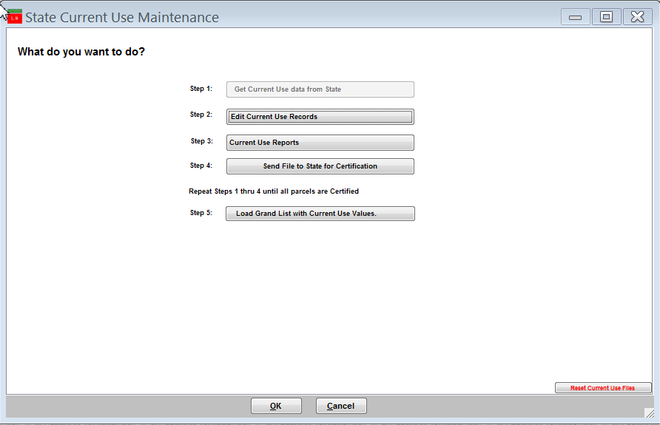
- Edit Each record accordingly. Each record must be ‘Validated’ by the listers before the file can be sent back to the State CU Dept.

3. Review any reports necessary

4. Send the file back to State CU Dept. Once the file is sent back to them you can not edit any data until they send you the file back.

5. Load Grand List with Current Use values. This is the process that moves the Current Use Reduction values into.
‘1. Parcel Maintenance’.

Current Use Process.

Download from State CU Dept

Edit accordingly

Send back to State CU Dept

Load CU exemptions into Grand List

You confirm your ‘411 report’ to the CU ‘All Parcels report’

Once loaded into ‘1 Parcel Maintenance’ go to the ‘R Reports’ menu and run ‘4 Form 411’ Make sure the Current Use row. Matches the totals on the ‘All Parcels Report’ from ‘9 Current Use Maintenance’. This is your manual check to make sure what you are reporting to the State CU Dept matches what you are reporting on your Grand List in ‘1 Parcel Maintenance’.

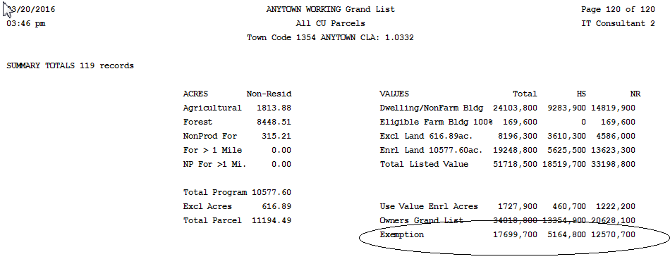

To the right is a copy of the last page of the ‘All Current Use Report’ compare the TOTAL, HS, and NR to the corresponding 411 columns.

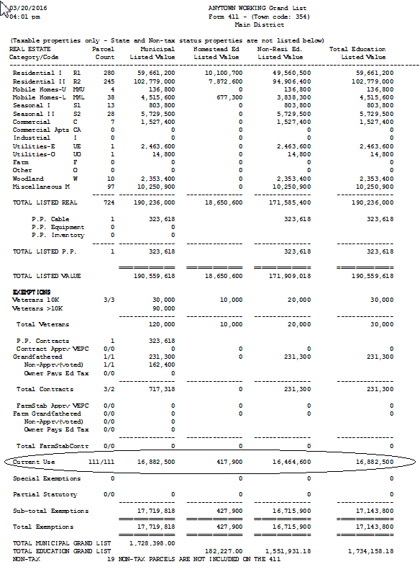
To the right is a copy of the 411 Report. Compare the ‘Current Use’ row to the ‘All Parcels Report’ above.

Start with the 1st columns on each report.

All Parcels Total = 17,699,700
Form 411 Muni = 16,882,500
817,200

Now you must uncover why these 2 reports
are different. In this example it is due to the fact ‘Purged’ parcels are included in the ‘All Parcels Report’ and purged parcels should not have a CU value in ‘1 Parcel Maintenance.

Once you have reconciled the first column move onto the Homestead and Non Residential columns.

Editing CU parcels.

When editing CU parcels pay special attention to the data entry fields.
- Any item that appears red in color means that the information showing up in ‘9 State Current Use Maintenance’ does not match ‘1 Parcel Maintenance’. Correct any issue you discover.
- When you place your mouse over certain areas of this screen such as; Names & address, Acres, and Values a window will appear in the upper right corner of the screen. This window reflects the same type of information on the ‘1 Parcel Maintenance’ screen. This saves you from closing out of this screen and going to look up information on the ‘1 Parcel Maintenance’ screen.

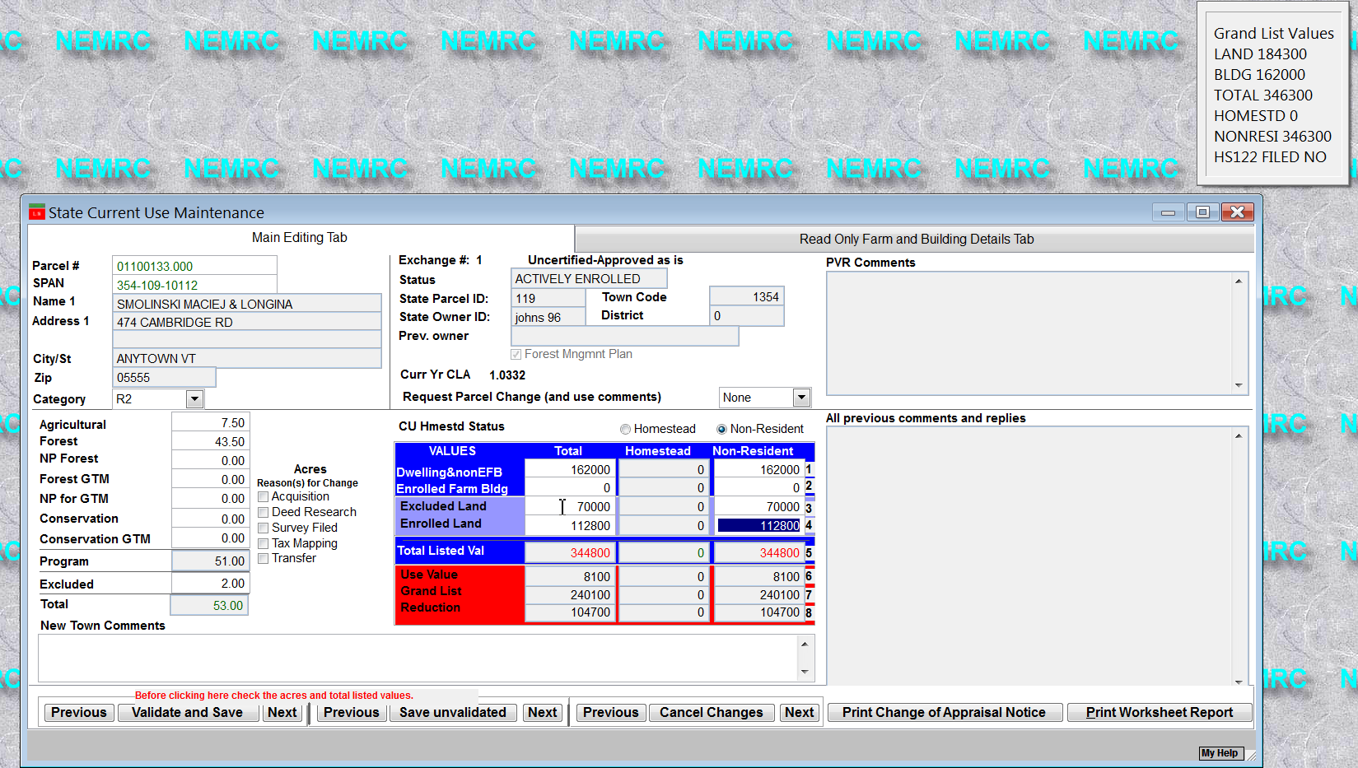

- Status – pay special attention to this field. This will tell you what is happening to this record. Below are a couple of status settings you should be aware of.

- You can no longer edit a parcel that has a status of ‘Pending’ or ‘Purge’
- ‘Town changes not applied’ The parcel will be reverted back to it’s previous information.

Questions:

- What 2 reports must you compare to insure all of your Current use exemptions were loaded into ‘1 Parcel Maintenance’?

- When Editing CU parcels what does it mean when an item is highlighted in ‘Red’?

- After you send data back to the State CU Dept can you edit your Current Use records? Yes / No

- When is your 1st current use file available for download? Circle one below
February – March – April

- If a parcel is flagged with a ‘Status’ of ‘Pending’ in ‘9 Current Use Maintenance’ can you edit that record? Yes / No

